

Parent/Teacher Conferences

*Conferences will be on Thursday, April 13th.*

Appointment slips will go home today. If you cannot make the time assigned to you, please let Sr. Suraiya or Sr. Becky know.

**Spelling Words**

1. barking
2. carpet
3. zipper
4. perfume
5. morning
6. forest
7. border
8. today



**First Grade**

**Sneak Preview**

**Week of March 27, 2017**



**Information for Reading A-Z will be coming home this week. There will be homework assignments based on this, so be sure that you are able to log-in!**

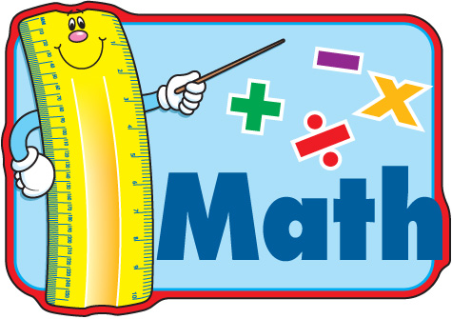

We will be doing subtraction from teen numbers by counting on or taking from groups of ten.

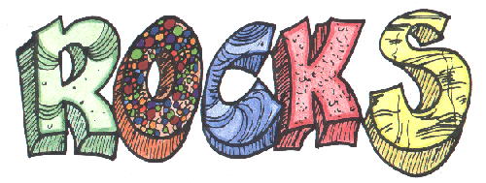

In Listening & Learning, we will continue talking about the History of the Earth. We will be covering minerals, types of rocks, and fossils.



**Scholastic Book Club orders for April will be due on April 3rd.**

**Thank you!**

